Exercise 5

WEBD1000

Carlos Ramos – W0467831

## Step 1:

Step 2:

Step 3:

Step 4:

Step 5:

Step 6:

Step 7:

Step 8:

Step 9:

Step 10:

Step 11:

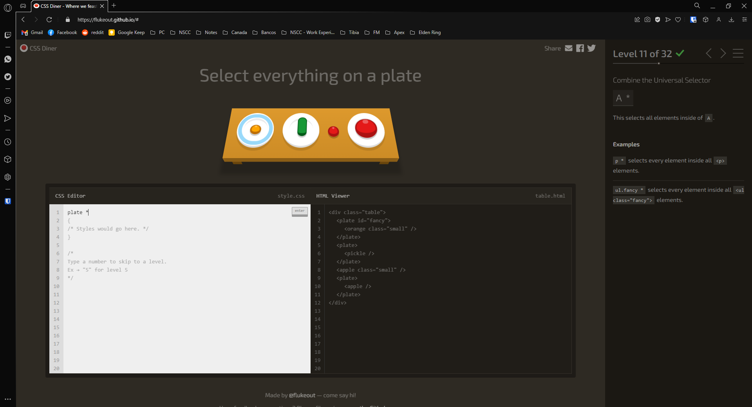

Step 12:

Step 13:

Step 14:

Overall steps:

